1. READING THE CHART

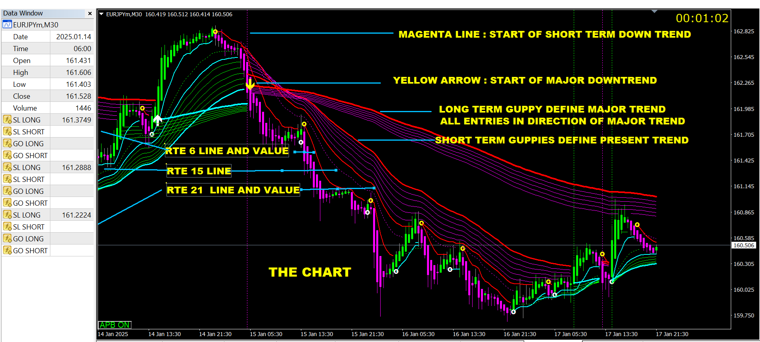

1. BASIC INTERPRETATION

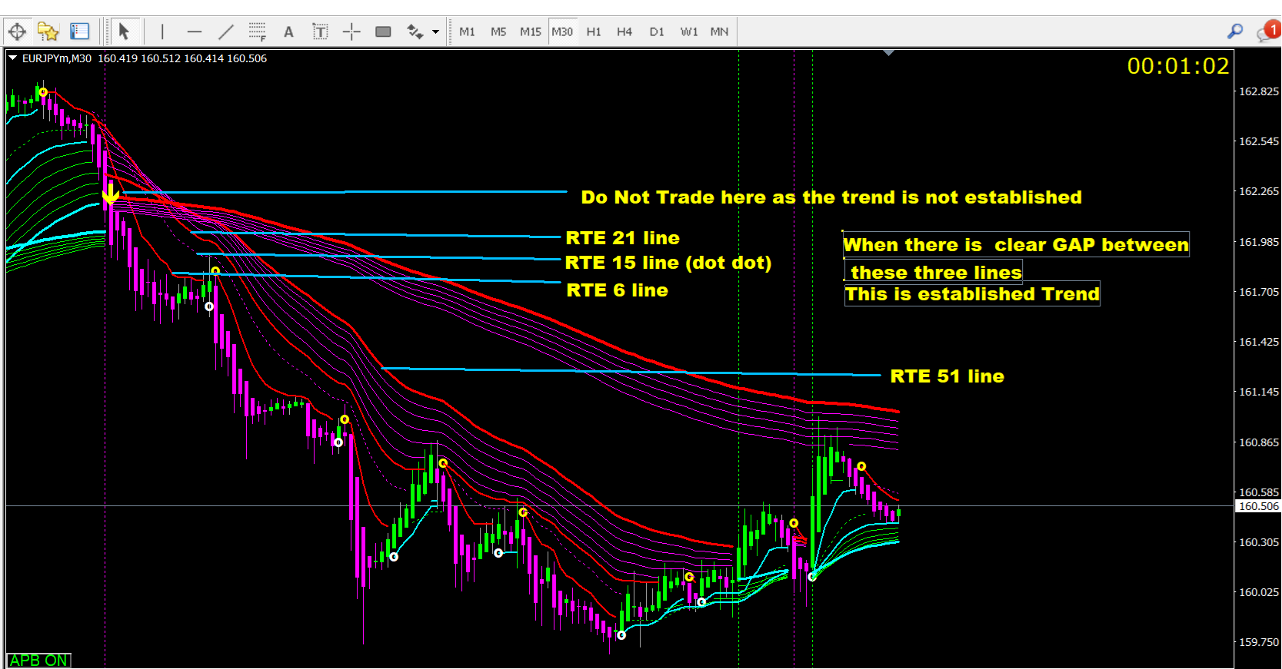

1. IDENTIFYING PULLBACKS

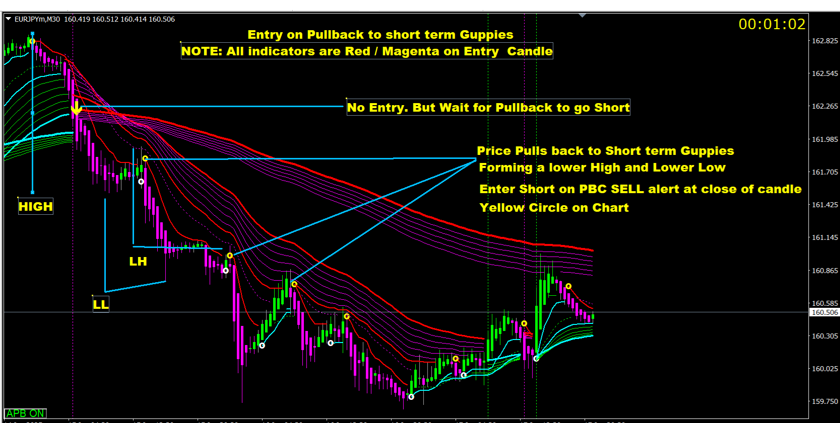

1. DOW THEORY IN THIS SETUP :

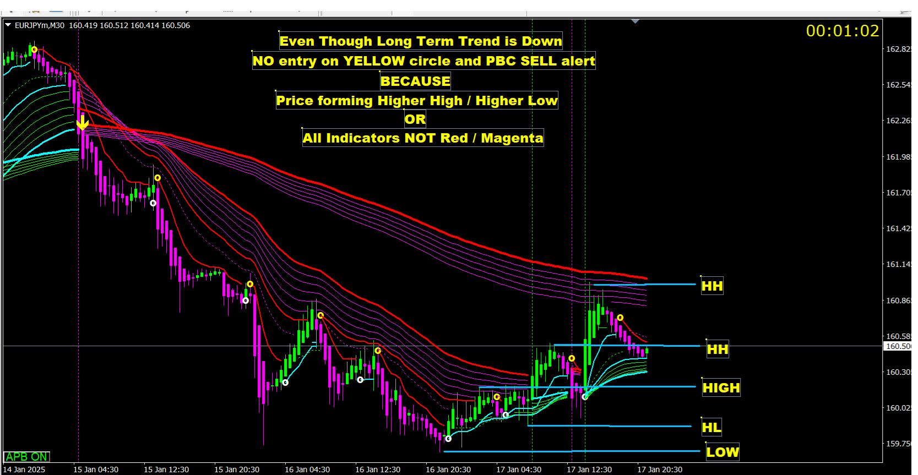

1. FLAGS, CHANNEL, TREND LINES

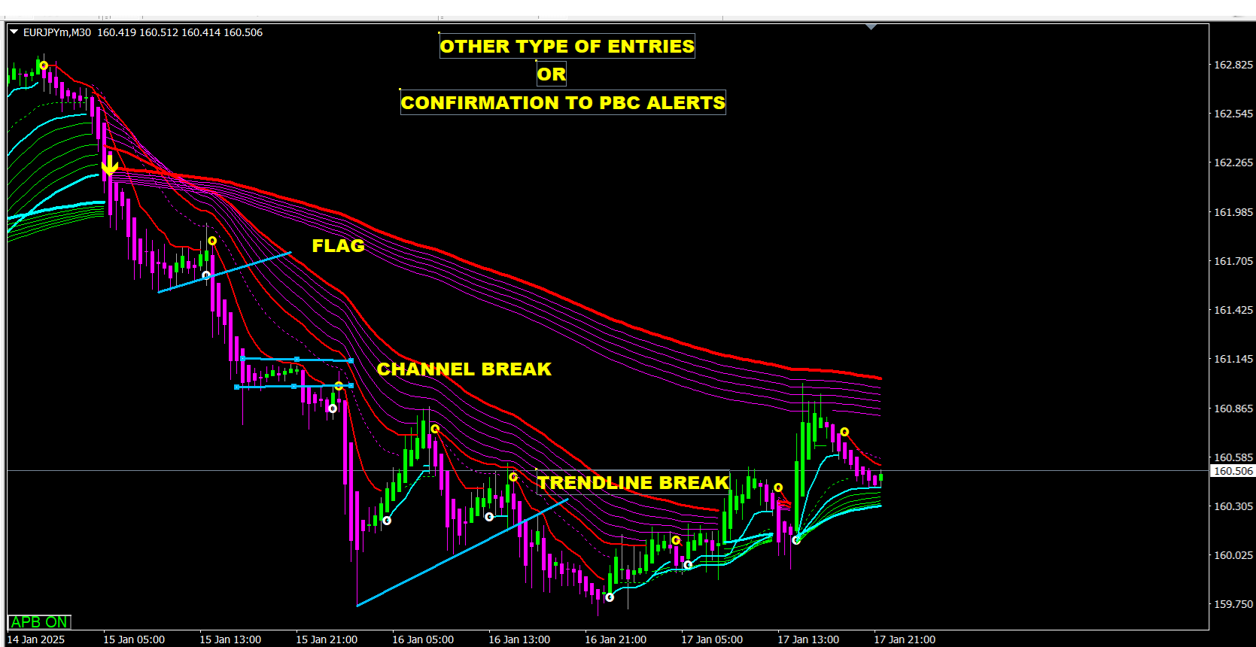

1. APB AND JAPANESE CANDLES

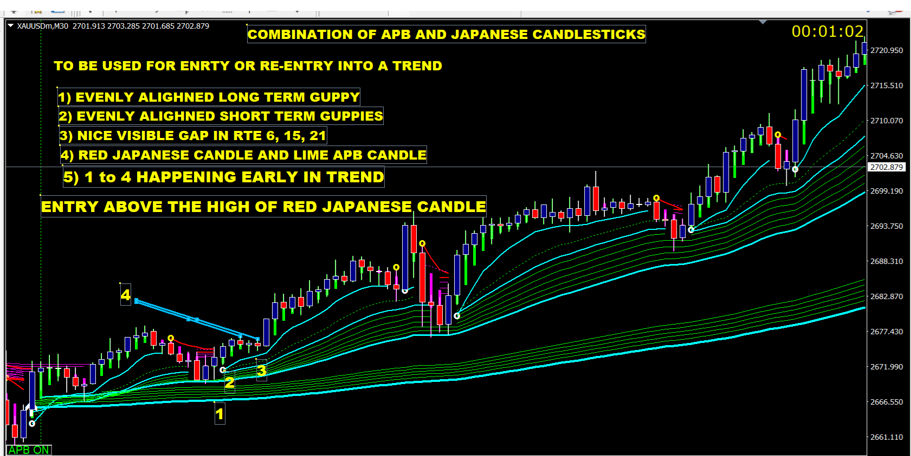

1. GUPPY AND APB

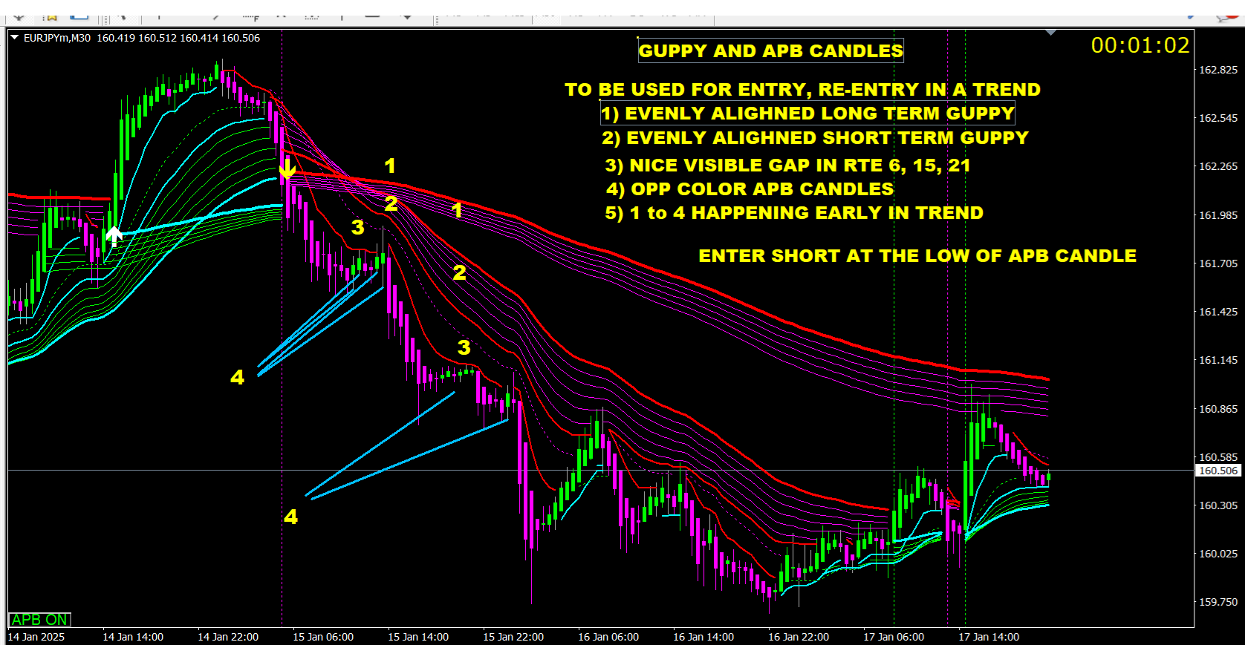

1. MANAGING TRADE

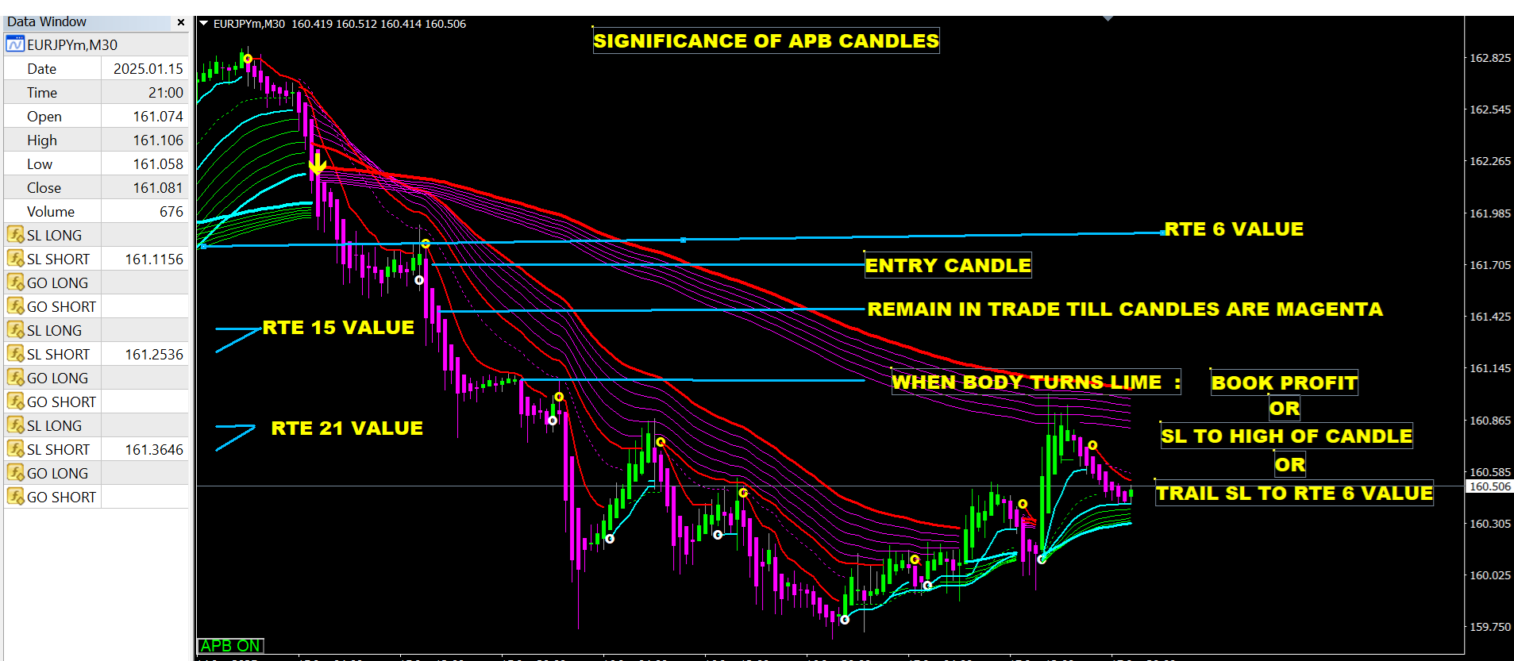

1. CHECKLIST

